Topic – java nio package part 3 🡪

**Basic file attribute example two-**

**Simplefilevisitor class not allowing to delete directory if it is not empty—**

Strange behaviour.

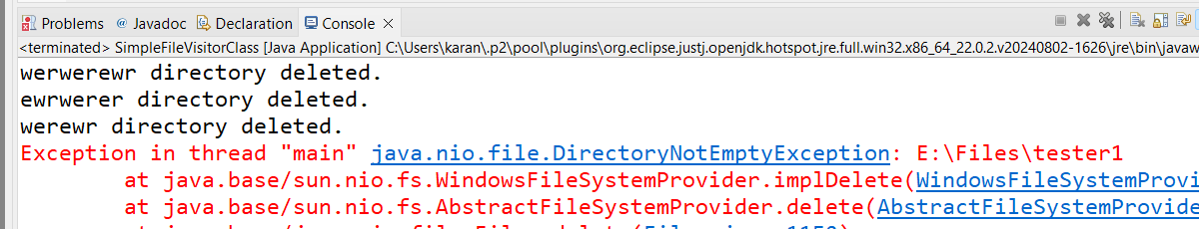

We have some files in some directories and sub directories –

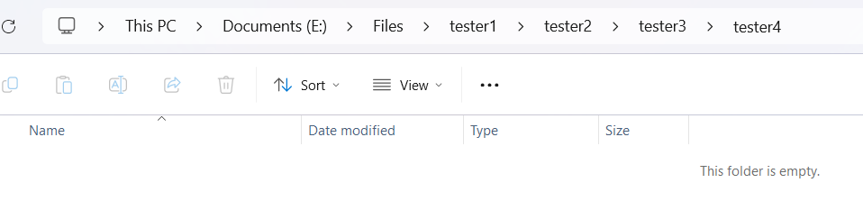

**SimpleFileVisitorClass-**

Same code with chatgpt correction –

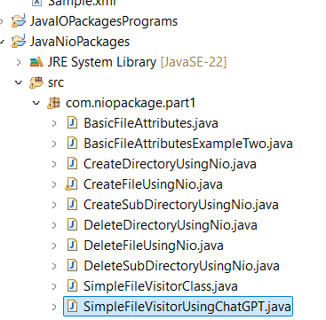

Again only those directories are deleted which are non-empty—

**StreamDirectoriesAndDeleteFilesAndDirectoriesRecursively-**

Removed directory not present in E drive –

Some issue with my pc—

This should search **E drive** for files ending in **.txt –**

**Searching files in nio-**

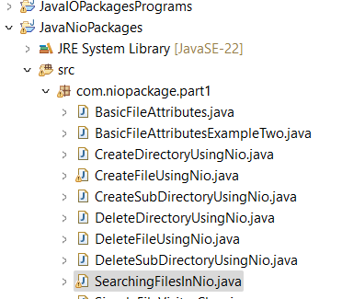

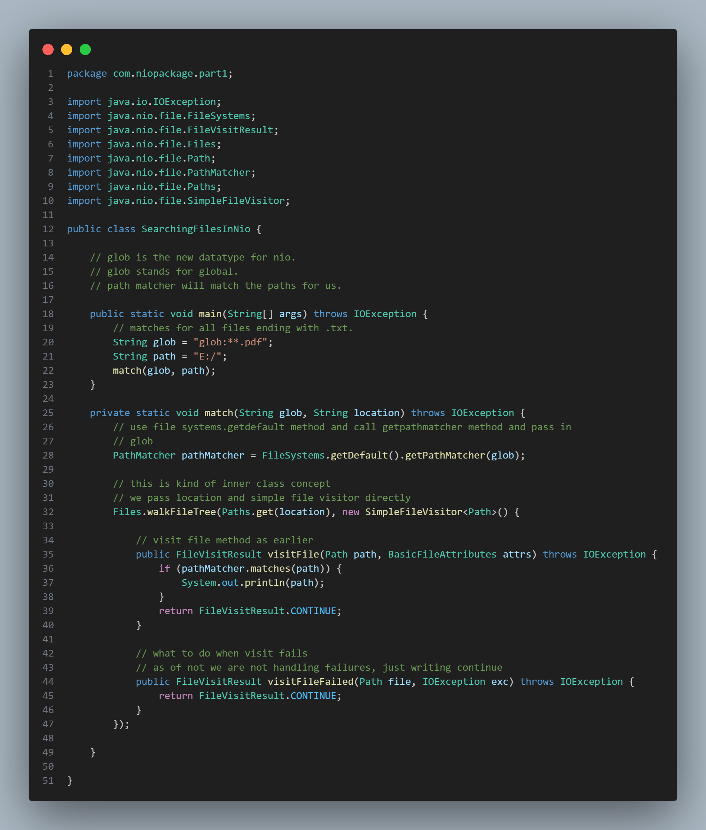

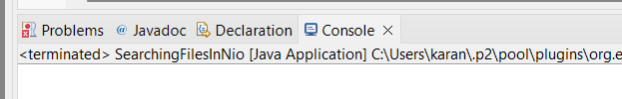

**Filesystem class definition –**

**Getdefault definition –**

Updated **line 30 –**



Added **line 20, 21, edited 22 with space--**

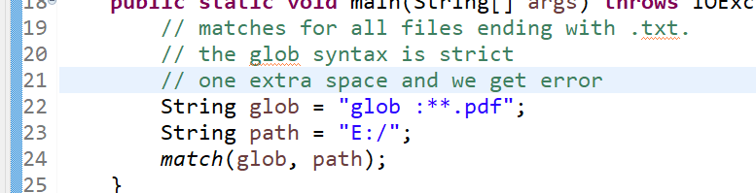

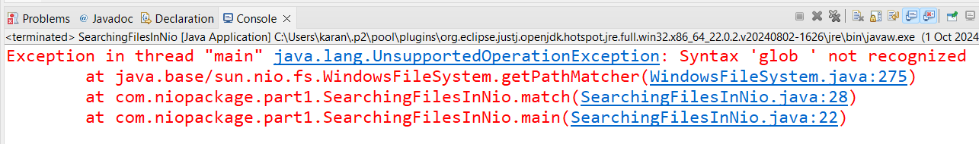

**If glob is written like this –**

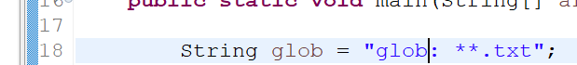

Now it’s working –

**AnotherWayOfSearchingFile-**

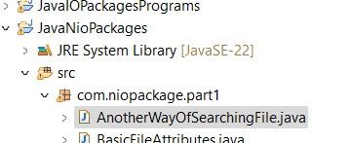

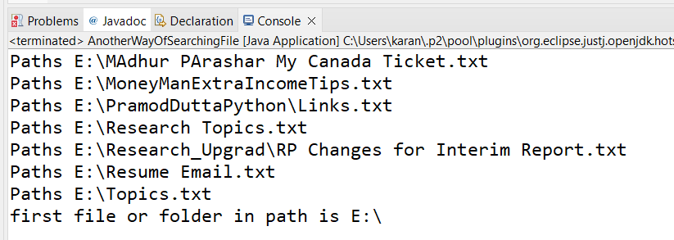

**Directory streaming-**

**Directory watcher-**

Added **line 25, 26, 27, 28 --**

